Dear Marketing Partner!

Heroes in Recovery is a movement ignited by Foundations Recovery Network and the widespread community of those who are in recovery from addiction and mental health disorders. We discovered that while 23 million people each year need help for addiction, only 4 million actually seek treatment. Heroes in Recovery has a simple mission: to eliminate the social stigma that keeps individuals with addiction and mental health issues from seeking help, to share stories of recovery for the purpose of encouragement and inspiration, and to create an engaged sober community that empowers people to get involved, give back and live healthy active lives.

We hold events across the country, seeking to inspire a sense of community. One of our main events is the national Heroes in Recovery 6K race series. These 3.728 mile races bring together those in recovery, their loved ones, supporters of the cause and whole communities in order to break the stigma surrounding addiction and mental health conditions. It takes a heroic effort to live clean and sober each day and a Heroes 6K celebrates that effort.

Each Heroes 6K race has a local charity beneficiary that receives a portion of the proceeds from the event. These charities have a connection with recovery and support our mission of helping people heal from addiction and mental health issues. Our goal is to aid local organizations in their efforts as we go from city to city spreading the word about Heroes in Recovery.

Attached for your consideration are the marketing sponsorship opportunities for 2015. If you need more information or details, please contact me at your convenience. We look forward to seeing you, at the finish line!

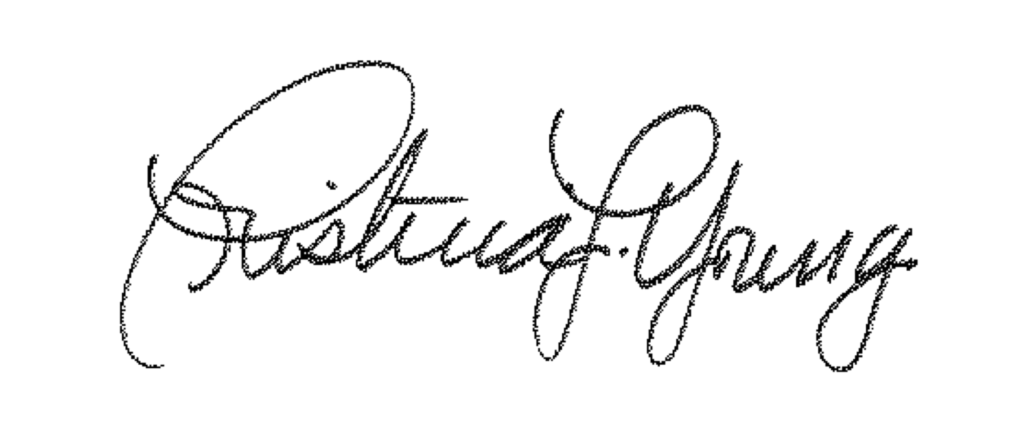
Sincerely,

Cristina Young

SPONSOR BENEFITS | SPONSOR CATEGORY | BAG INSERT $100 | (15) EXHIBITOR $250 | (10) SILVER $500 | (1) WATER STATION $1,500 | (3) GOLD $2,500 | (3) PLATINUM $5,000 | (1) THE GOODIE BAG $7,500 | (1) PRESENTING $15,000
COMPANY PROMOTIONAL MATERIAL IN GOODIE BAGS
EMAIL RECOGNITION |  |  |  |  |  |  |  | Plus Logo | Plus Logo
EXHIBITOR TABLE |  |  |  |  |  |  |  | With Tent | With Tent
LOUD SPEAKER RECOGNITION
*LOGO ON RACE SHIRT
FREE RACE ENTRIES |  |  |  | 2 Entries | 3 Entries | 4 Entries | 5 Entries | 7 Entries | 10 Entries
LOGO ON WEBSITE or AT COURSE WATER STOP |  |  |  |  | 2 Water Station signs | Plus Logo | Plus Logo | Plus Logo | Plus Logo
LOGO ON PRINT MATERIAL or GOODIE BAGS |  |  |  |  |  |  |  | Recycled Goodie Bags
RECOGNITION ON PRESS RELEASE - MEDIA EVENTS
ADDRESS THE CROWD
COMPANY LOGO ON START/FINISH BANNER
INPUT ON EVENT LOCATION/CHARITY BENEFICIARY
All sponsor benefits associated with printed materials (posters, postcards, t-shirts etc…) are subject to printing deadlines.
Don’t see a level that best suits you? Contact me to discuss a custom sponsorship option. cristina.young@frnmail.com

Please Mail Payment to:

Foundations Recovery Network
Attn: Heroes 6K
5409 Maryland Way, Ste. 320
Brentwood, TN 37027
PLEASE BE SURE TO REFERENCE [CITY] HEROES 6K

How you can help with the movement:

FACEBOOK: Please like our page:
https://www.facebook.com/HeroesinRecovery

TWITTER: Please follow us and mention the race in your tweets:
http://twitter.com/Heroes6KRD
https://twitter.com/HeroesNRecovery

WEBSITE: Please share our website for race information and registration:
http://www.heroes6k.com

Guidelines for submitting your logo:

Email a high-resolution vector file of preferred logo to:
mailto:cristina.young@frnmail.com
Image should be at least 500x500 pixels in size
File Types: PNG, JPEG, PDF, AI or EPS

Our Locations for 2015/2016:

Atlanta, GA – July 25, 2015 (Brook Run Park)
Louisville CO – August 1, 2015 (Louisville Community Park)
Leiper’s Fork, TN – September 12, 2015 (Old Hillsboro Pike)
Charlotte, NC – September 27, 2015 (University Research Park)
Malibu, CA – October 18, 2015 (Paramount Ranch)
San Diego, CA – November 8, 2015 (De Anza Cove Park, Mission Bay)
Arizona – December 20, 2015 (Riparian Preserve at Water Ranch)
Palm Springs, CA – February 6, 2016
Coconut Creek, FL – TBD 2016
Memphis, TN – TBD 2016

